**How to create static library and access it**

* 1. Create 2 folders inside
  + C:\MyCpp
  + **developer and client**
  1. go to Visual Studio 2022
* File
* Close solution [ if any project is open ]
  1. Create new project
* Select:
* **Static library**



* Next
* Name “**devpro**”
* Location **c:\MyCpp\developer\**
* Select – place project and solution in the same directory.
* Click on “create”
  1. In the generated “pch.h” file make sure following contents are there:
* #ifndef PCH_H
* #define PCH_H
* // add headers that you want to pre-compile here

#include "framework.h"

#include <iostream>

using namespace std;

#endif //PCH_H

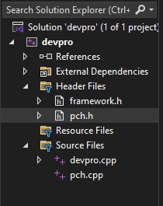 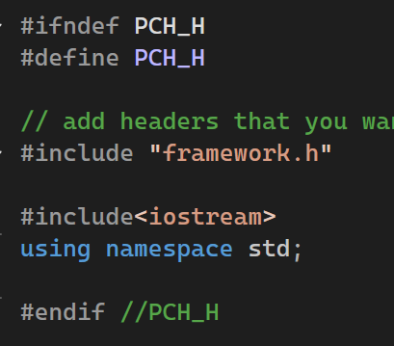

* 1. Right click on “devpro”
* Add
* New item
* Select “header file (.h) “
* Name “myheader.h”
* add
* Type the following

void disp();

* And “save”.



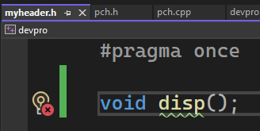

* 1. Inside generated “devpro.cpp” write the following code:

/* in the generated “pch.h” file we’ve already

Included “iostream” and “std namespace” , so no need to repeat here

*/

#include "pch.h"

void disp()

{

cout << "welcome to static library function" << endl;

}

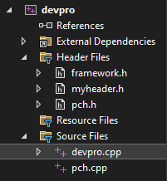

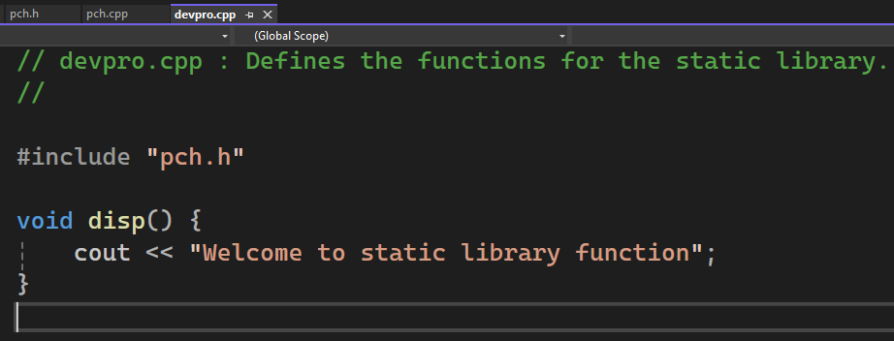

* 1. Compile it. – Build
* Compile [ ctrl + F7 ]
  1. Build it [ ctrl+shift+B ]
* Maku sure it will create “devpro.lib”

Inside “C:\MyCpp\developer\devpro\x64\Debug”

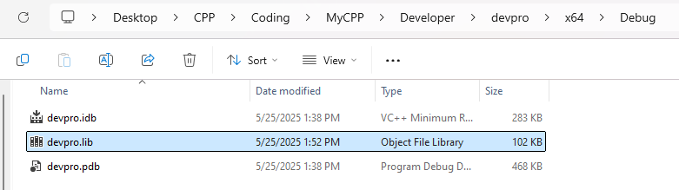

* 1. Copy “devpro.lib” and “myheader.h” and to “c:\forclient” folder.

“c:\forclient” folder is the one which you have to create in order to share files between client and developer.

C:\Users\Admin\Desktop\CPP\Coding\MyCPP\Developer\devpro\x64\Debug\devpro.lib

C:\Users\Admin\Desktop\CPP\Coding\MyCPP\Developer\devpro\myheader.h

**Open one more instance of Visual Studio 2022**

1. Create new project

* Console App
* Name : clientpro
* Location: C:\MyCpp\client
* Select - place both solution and projects in the same directory.
* Click on “Create”

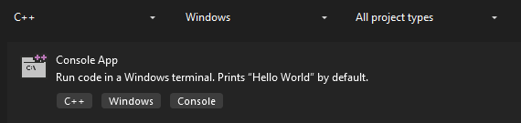

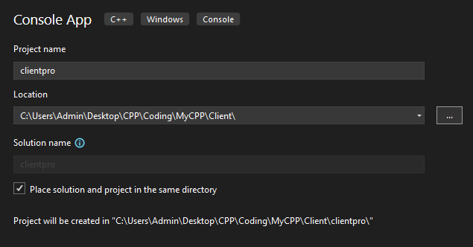

1. Inside the generated “clientpro.cpp” file make following changes:

#include <iostream>

using namespace std;

int main()

{

cout << "Before Calling"<<endl;

disp();

cout << "After Calling" << endl;

}

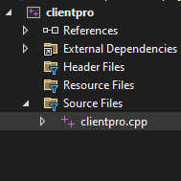

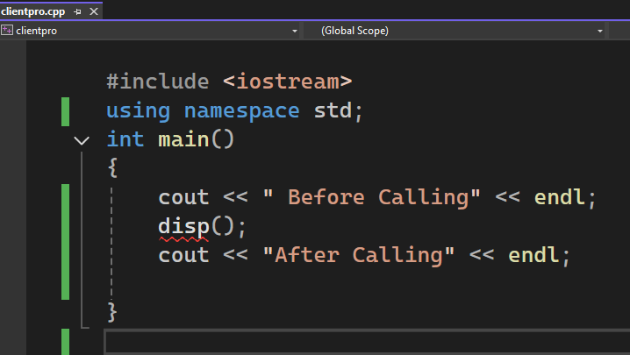

1. And compile. It will give compiler error

* Identifier “disp” is undefined.

1. Add following statement in the above code

#include "c:\forclient\myheader.h"

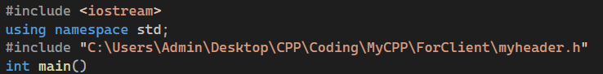

#include “C:\Users\Admin\Desktop\CPP\Coding\MyCPP\ForClient\myheader.h”

1. Save and compile. [ ctrl + F7 ]

* It will compile successfully.

1. Now build it.[ ctrl+shift+B ]

* It will give u linking error. [ disp body not found]
* to solve this problem:
* right click on “clientpro”
* properties
* configuration properties
* linker
* input
* Additional Dependencies
* From the right side button select “Additional Dependencies window”
* Click “Edit”

And type “c:\forclient\devpro.lib”.

* Click on “apply” and “ok”
* Save

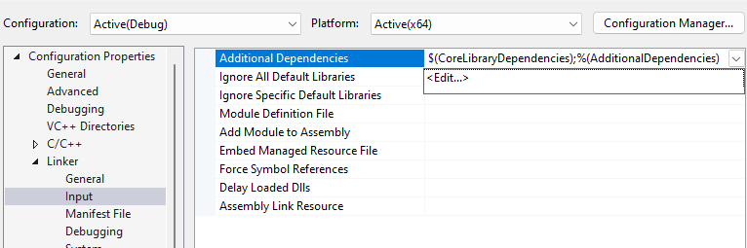



1. Click on build. [ ctrl +shift+B ]

[ do not compile , it’s not needed as we need to convince “linker” only and not the compiler about the body of “disp” which is there in “devpro.lib” file ]

It will buid successfully and create clientpro.exe

1. Press ctrl+f5 to run. It will run successfully.

OP:

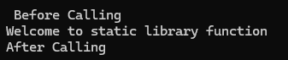

**What is pch.h file**

pch.h stands for "precompiled header." It's commonly used in C++ projects to improve compilation times by precompiling common header files.

When you create a static library in C++, you might have multiple source files that include the same set of header files. Instead of re-parsing these headers for each source file during compilation, you can include them once in a pch.h file and precompile it. This way, the compiler only needs to parse the headers once, reducing compilation time for your project.